Lab 08 – Worksheet

Name: Muhammad Zubair Asif | ID: ma11925 | Section: T1

Note: Assumptions and logics should be explained separately in tasks after the task results.

Task 1
Block Diagram
a) Data Memory Module
b) Address Decoder
c) Top Module

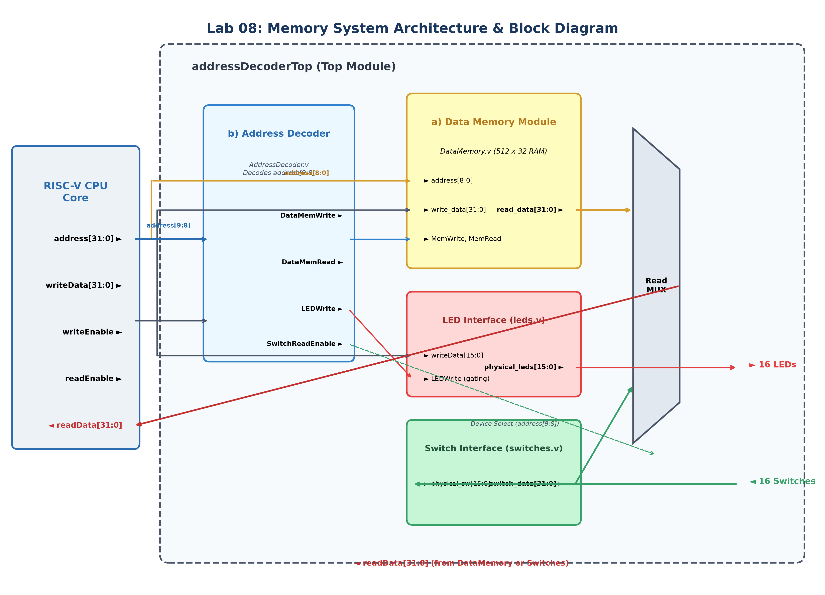
a) Data Memory Module (DataMemory.v): 512 x 32 RAM array; synchronous write on posedge clk gated by MemWrite; asynchronous combinational read gated by MemRead (single-cycle timing).
b) Address Decoder (AddressDecoder.v): Combinational decoder evaluating address[9:8] to generate mutually exclusive device enables (DataMemWrite, DataMemRead, LEDWrite, SwitchReadEnable).
c) Top Module (addressDecoderTop.v): Integrates CPU memory bus with Data Memory, MMIO LED interface, MMIO Switch interface, and the Read Data Multiplexer.

Comments
1. Memory Mapping & Addressing Logic: The processor presents a 32-bit address, but only the 10 least significant bits address[9:0] are decoded locally to form a 1024-word memory space. Bits address[9:8] select the device: 2'b00 selects Data Memory (locations 0-511, read/write); 2'b01 selects LEDs (locations 512-767, write-only); 2'b10 selects Switches (locations 768-1023, read-only); 2'b11 is unused.
2. Timing Conventions: Write operations are synchronous to posedge clk to guarantee stable data capture. Memory read is asynchronous (combinational) to satisfy single-cycle RISC-V timing, allowing the LW instruction to retrieve data in the same clock cycle.
3. Mutual Exclusion & Isolation: Gated enable signals guarantee mutual exclusion, preventing bus contention. Disallowed transactions (writes to switch addresses or reads from LED addresses) are safely ignored and return zero.

Task 2

Modules for DataMemory, AddressDecoder, AddressDecoderTop, Switches and Leds.
// ==================== 1. DataMemory.v ====================
`timescale 1ns / 1ps
//////////////////////////////////////////////////////////////////////////////////
// Company:
// Engineer:
//
// Create Date: 10/15/2026 03:00:00 PM
// Design Name:
// Module Name: DataMemory
// Project Name:
// Target Devices:
// Tool Versions:
// Description:
//
// Dependencies:
//
// Revision:
// Revision 0.01 - File Created
// Additional Comments:
//
//////////////////////////////////////////////////////////////////////////////////
module DataMemory #(
parameter DEPTH = 512,
parameter DATA_WIDTH = 32,
parameter ADDR_WIDTH = 9
)(
input wire clk,
input wire rst,
input wire MemWrite,
input wire MemRead,
input wire [ADDR_WIDTH-1:0] address,
input wire [DATA_WIDTH-1:0] write_data,
output wire [DATA_WIDTH-1:0] read_data
);
// 512 locations of 32-bit memory array
reg [DATA_WIDTH-1:0] memory [0:DEPTH-1];
integer i;
// Initialize all memory locations to 0
initial begin
for (i = 0; i < DEPTH; i = i + 1) begin
memory[i] = {DATA_WIDTH{1'b0}};
end
end
// Synchronous write and synchronous reset
always @(posedge clk) begin
if (rst) begin
for (i = 0; i < DEPTH; i = i + 1) begin
memory[i] <= {DATA_WIDTH{1'b0}};
end
end else if (MemWrite) begin
memory[address] <= write_data;
end
end
// Asynchronous read (single-cycle processor convention)
// If MemRead is high, return data at address; otherwise output 0
assign read_data = (MemRead) ? memory[address] : {DATA_WIDTH{1'b0}};
endmodule
// ==================== 2. AddressDecoder.v ====================
`timescale 1ns / 1ps
//////////////////////////////////////////////////////////////////////////////////
// Company:
// Engineer:
//
// Create Date: 10/15/2026 03:05:00 PM
// Design Name:
// Module Name: AddressDecoder
// Project Name:
// Target Devices:
// Tool Versions:
// Description:
//
// Dependencies:
//
// Revision:
// Revision 0.01 - File Created
// Additional Comments:
//
//////////////////////////////////////////////////////////////////////////////////
module AddressDecoder (
input wire [31:0] address,
input wire readEnable,
input wire writeEnable,
output wire DataMemWrite,
output wire DataMemRead,
output wire LEDWrite,
output wire SwitchReadEnable,
output wire DataMemSelect,
output wire LEDSelect,
output wire SwitchSelect
);
// Device selection based on address[9:8] (Lab 8 Manual Table)
assign DataMemSelect = (address[9:8] == 2'b00);
assign LEDSelect = (address[9:8] == 2'b01);
assign SwitchSelect = (address[9:8] == 2'b10);
// Gated enables ensuring mutual exclusion and preventing bus contention
// 1. Data Memory: supports both read and write
assign DataMemWrite = writeEnable && DataMemSelect;
assign DataMemRead = readEnable && DataMemSelect;
// 2. LEDs: write-only interface
assign LEDWrite = writeEnable && LEDSelect;
// 3. Switches: read-only interface
assign SwitchReadEnable = readEnable && SwitchSelect;
endmodule
// ==================== 3. addressDecoderTop.v ====================
`timescale 1ns / 1ps
//////////////////////////////////////////////////////////////////////////////////
// Company:
// Engineer:
//
// Create Date: 10/15/2026 03:10:00 PM
// Design Name:
// Module Name: addressDecoderTop
// Project Name:
// Target Devices:
// Tool Versions:
// Description:
//
// Dependencies:
//
// Revision:
// Revision 0.01 - File Created
// Additional Comments:
//
//////////////////////////////////////////////////////////////////////////////////
module addressDecoderTop (
input wire clk,
input wire rst,
input wire [31:0] address,
input wire readEnable,
input wire writeEnable,
input wire [31:0] writeData,
input wire [15:0] switches,
output wire [31:0] readData,
output wire [15:0] leds
);
// 1. Decoder Enable & Select Signals
wire DataMemWrite;
wire DataMemRead;
wire LEDWrite;
wire SwitchReadEnable;
wire DataMemSelect;
wire LEDSelect;
wire SwitchSelect;
AddressDecoder decoder_inst (
.address(address),
.readEnable(readEnable),
.writeEnable(writeEnable),
.DataMemWrite(DataMemWrite),
.DataMemRead(DataMemRead),
.LEDWrite(LEDWrite),
.SwitchReadEnable(SwitchReadEnable),
.DataMemSelect(DataMemSelect),
.LEDSelect(LEDSelect),
.SwitchSelect(SwitchSelect)
);
// 2. Data Memory Instantiation (512 locations x 32 bits)
wire [31:0] data_mem_out;
DataMemory #(
.DEPTH(512),
.DATA_WIDTH(32),
.ADDR_WIDTH(9)
) data_mem_inst (
.clk(clk),
.rst(rst),
.MemWrite(DataMemWrite),
.MemRead(DataMemRead),
.address(address[8:0]),
.write_data(writeData),
.read_data(data_mem_out)
);
// 3. Switch Interface Instantiation (Lab 5 switch module)
wire [31:0] switch_data_out;
switches switch_interface (
.physical_sw(switches),
.switch_data(switch_data_out)
);
// 4. LED Interface Instantiation (Lab 5 leds module)
// To allow leds.v to retain its state when LEDWrite is not asserted,
// feed back the current LED output unless a write occurs.
wire [15:0] leds_internal;
wire [31:0] led_write_bus = (LEDWrite) ? writeData : {16'd0, leds_internal};
leds led_interface (
.clk(clk),
.rst(rst),
.writeData(led_write_bus),
.physical_leds(leds_internal)
);
assign leds = leds_internal;
// 5. Read Data Multiplexer
// Routes DataMemory or Switches to CPU readData, defaulting to 0 on inactive/invalid reads.
assign readData = (DataMemSelect && DataMemRead) ? data_mem_out :
(SwitchSelect && SwitchReadEnable) ? switch_data_out :
32'd0;
endmodule
// ==================== 4. switches.v ====================
`timescale 1ns / 1ps
//////////////////////////////////////////////////////////////////////////////////
// Company:
// Engineer: Muddassir Ali
//
// Module Name: switches
// Project Name: Counter
// Target Devices: Baasys 3
//
//////////////////////////////////////////////////////////////////////////////////
module switches(
input [15:0] physical_sw,
output [31:0] switch_data
);
assign switch_data = {16'd0, physical_sw};
endmodule
// ==================== 5. leds.v ====================
`timescale 1ns / 1ps
//////////////////////////////////////////////////////////////////////////////////
// Company:
// Engineer: Muddassir Ali
//
// Module Name: leds
// Project Name: Counter
// Target Devices: Baasys 3
//
//////////////////////////////////////////////////////////////////////////////////
module leds(
input clk,
input rst,
input [31:0] writeData,
output reg [15:0] physical_leds
);
always @(posedge clk) begin
if (rst)
physical_leds <= 16'd0;
else
physical_leds <= writeData[15:0];
end
endmodule

Testbench:
// ==================== MemorySystem_tb.v (Self-Checking Testbench) ====================
`timescale 1ns / 1ps
//////////////////////////////////////////////////////////////////////////////////
// Company:
// Engineer:
//
// Create Date: 10/15/2026 03:15:00 PM
// Design Name:
// Module Name: MemorySystem_tb
// Project Name:
// Target Devices:
// Tool Versions:
// Description:
//
// Dependencies:
//
// Revision:
// Revision 0.01 - File Created
// Additional Comments:
//
//////////////////////////////////////////////////////////////////////////////////
module MemorySystem_tb;
reg clk;
reg rst;
reg [31:0] address;
reg readEnable;
reg writeEnable;
reg [31:0] writeData;
reg [15:0] switches;
wire [31:0] readData;
wire [15:0] leds;
integer errors = 0;
// Instantiate Device Under Test (DUT)
addressDecoderTop dut (
.clk(clk),
.rst(rst),
.address(address),
.readEnable(readEnable),
.writeEnable(writeEnable),
.writeData(writeData),
.switches(switches),
.readData(readData),
.leds(leds)
);
// Clock generation: 100MHz (10ns period)
always #5 clk = ~clk;
initial begin
$dumpfile("waveform.vcd");
$dumpvars(0, MemorySystem_tb);
$display("===================================================================");
$display(" Starting Lab 8 Memory System & Address Decoder Tests ");
$display("===================================================================");
// Initial setup
clk = 0;
rst = 1;
address = 32'd0;
readEnable = 0;
writeEnable = 0;
writeData = 32'd0;
switches = 16'h0000;
// Apply reset for 2 clock cycles
#20;
rst = 0;
#10;
// -------------------------------------------------------------------------
// TEST 1: Data Memory Write & Read Back (address[9:8] == 2'b00)
// -------------------------------------------------------------------------
$display("\n--- TEST 1: Data Memory Write and Read-Back ---");
// Write to address 0 (address[9:8] = 00, local 0)
@(posedge clk);
address = 32'h0000_0000;
writeData = 32'hDEADBEEF;
writeEnable = 1;
readEnable = 0;
@(posedge clk);
writeEnable = 0;
// Write to address 10 (address[9:8] = 00, local 10)
@(posedge clk);
address = 32'h0000_000A;
writeData = 32'hCAFE1234;
writeEnable = 1;
@(posedge clk);
writeEnable = 0;
// Write to address 255 (address[9:8] = 00, local 255)
@(posedge clk);
address = 32'h0000_00FF;
writeData = 32'h55AA33CC;
writeEnable = 1;
@(posedge clk);
writeEnable = 0;
// Read back from address 0
@(posedge clk);
address = 32'h0000_0000;
readEnable = 1;
#1; // combinational read settling
if (readData === 32'hDEADBEEF) begin
$display("[PASS] Read Memory[0]: Expected 32'hDEADBEEF, Got 32'h%h", readData);
end else begin
$display("[FAIL] Read Memory[0]: Expected 32'hDEADBEEF, Got 32'h%h", readData);
errors = errors + 1;
end
// Read back from address 10
@(posedge clk);
address = 32'h0000_000A;
readEnable = 1;
#1;
if (readData === 32'hCAFE1234) begin
$display("[PASS] Read Memory[10]: Expected 32'hCAFE1234, Got 32'h%h", readData);
end else begin
$display("[FAIL] Read Memory[10]: Expected 32'hCAFE1234, Got 32'h%h", readData);
errors = errors + 1;
end
// Read back from address 255
@(posedge clk);
address = 32'h0000_00FF;
readEnable = 1;
#1;
if (readData === 32'h55AA33CC) begin
$display("[PASS] Read Memory[255]: Expected 32'h55AA33CC, Got 32'h%h", readData);
end else begin
$display("[FAIL] Read Memory[255]: Expected 32'h55AA33CC, Got 32'h%h", readData);
errors = errors + 1;
end
readEnable = 0;
// -------------------------------------------------------------------------
// TEST 2: Memory-Mapped LEDs Write (address[9:8] == 2'b01)
// -------------------------------------------------------------------------
$display("\n--- TEST 2: Memory-Mapped LEDs Write ---");
// Write 0xABCD to LEDs (address[9:8] = 2'b01 -> address = 0x100 or 0x110)
@(posedge clk);
address = 32'h0000_0100; // address[9:8] = 2'b01
writeData = 32'h0000_ABCD;
writeEnable = 1;
readEnable = 0;
@(posedge clk);
#1;
if (leds === 16'hABCD) begin
$display("[PASS] Write LEDs (0xABCD): LEDs correctly show 16'h%h", leds);
end else begin
$display("[FAIL] Write LEDs (0xABCD): Expected 16'hABCD, Got 16'h%h", leds);
errors = errors + 1;
end
// Overwrite LEDs with 0x1234 at another LED offset (e.g. 0x110)
@(posedge clk);
address = 32'h0000_0110; // address[9:8] = 2'b01
writeData = 32'hFFFF_1234;
writeEnable = 1;
@(posedge clk);
#1;
if (leds === 16'h1234) begin
$display("[PASS] Overwrite LEDs (0x1234): LEDs correctly show 16'h%h", leds);
end else begin
$display("[FAIL] Overwrite LEDs (0x1234): Expected 16'h1234, Got 16'h%h", leds);
errors = errors + 1;
end
writeEnable = 0;
// -------------------------------------------------------------------------
// TEST 3: Memory-Mapped Switches Read (address[9:8] == 2'b10)
// -------------------------------------------------------------------------
$display("\n--- TEST 3: Memory-Mapped Switches Read ---");
// Set physical switch pattern 1
switches = 16'hF0F0;
@(posedge clk);
address = 32'h0000_0200; // address[9:8] = 2'b10
readEnable = 1;
writeEnable = 0;
#1;
if (readData === 32'h0000_F0F0) begin
$display("[PASS] Read Switches (0xF0F0): CPU readData = 32'h%h", readData);
end else begin
$display("[FAIL] Read Switches (0xF0F0): Expected 32'h0000F0F0, Got 32'h%h", readData);
errors = errors + 1;
end
// Change switch pattern 2
switches = 16'hA55A;
#1;
if (readData === 32'h0000_A55A) begin
$display("[PASS] Read Switches dynamic change (0xA55A): CPU readData = 32'h%h", readData);
end else begin
$display("[FAIL] Read Switches dynamic change (0xA55A): Expected 32'h0000A55A, Got 32'h%h", readData);
errors = errors + 1;
end
readEnable = 0;
// -------------------------------------------------------------------------
// TEST 4: Address Decoder Isolation & Contention Verification
// -------------------------------------------------------------------------
$display("\n--- TEST 4: Decoder Isolation & Mutual Exclusion ---");
// 4A: Write to Data Memory must NOT alter LEDs
@(posedge clk);
address = 32'h0000_0005; // Memory address
writeData = 32'h9999_9999;
writeEnable = 1;
@(posedge clk);
#1;
if (leds === 16'h1234) begin
$display("[PASS] Memory write does NOT corrupt LEDs: LEDs remain 16'h%h", leds);
end else begin
$display("[FAIL] Memory write corrupted LEDs! LEDs = 16'h%h", leds);
errors = errors + 1;
end
// 4B: Attempt to write to Switch address (read-only) must be ignored
@(posedge clk);
address = 32'h0000_0200; // Switch address
writeData = 32'hDEAD_BEEF;
writeEnable = 1;
@(posedge clk);
#1;
if (leds === 16'h1234) begin
$display("[PASS] Write to read-only Switch address is safely ignored");
end else begin
$display("[FAIL] Write to Switch address leaked to LEDs! LEDs = 16'h%h", leds);
errors = errors + 1;
end
// 4C: Attempt to read from LED address (write-only) should return 0
@(posedge clk);
address = 32'h0000_0100; // LED address
writeEnable = 0;
readEnable = 1;
#1;
if (readData === 32'd0) begin
$display("[PASS] Read from write-only LED address returns 32'h00000000");
end else begin
$display("[FAIL] Read from LED address returned non-zero: 32'h%h", readData);
errors = errors + 1;
end
// 4D: Access to unused address space (address[9:8] == 2'b11) returns 0
@(posedge clk);
address = 32'h0000_0300; // Unused address (2'b11)
writeEnable = 1;
writeData = 32'hFFFF_FFFF;
readEnable = 1;
@(posedge clk);
#1;
if (readData === 32'd0 && leds === 16'h1234) begin
$display("[PASS] Access to Unused address space (2'b11) has no side-effects and returns 0");
end else begin
$display("[FAIL] Unused address access caused unwanted side-effects! readData=%h, leds=%h", readData, leds);
errors = errors + 1;
end
// 4E: Read without readEnable returns 0
@(posedge clk);
address = 32'h0000_0000; // Memory has DEADBEEF
readEnable = 0;
writeEnable = 0;
#1;
if (readData === 32'd0) begin
$display("[PASS] Read with readEnable=0 returns 32'h00000000");
end else begin
$display("[FAIL] Read with readEnable=0 returned data: 32'h%h", readData);
errors = errors + 1;
end
// -------------------------------------------------------------------------
// Final Summary
// -------------------------------------------------------------------------
$display("\n===================================================================");
if (errors == 0) begin
$display(" *** ALL TESTS PASSED SUCCESSFULLY! (0 Errors) *** ");
$display(" Data Memory, Address Decoder, LEDs, and Switches are verified! ");
end else begin
$display(" *** TEST FAILED WITH %0d ERROR(S) *** ", errors);
end
$display("===================================================================\n");
#20;
$finish;
end
endmodule

Waveforms:
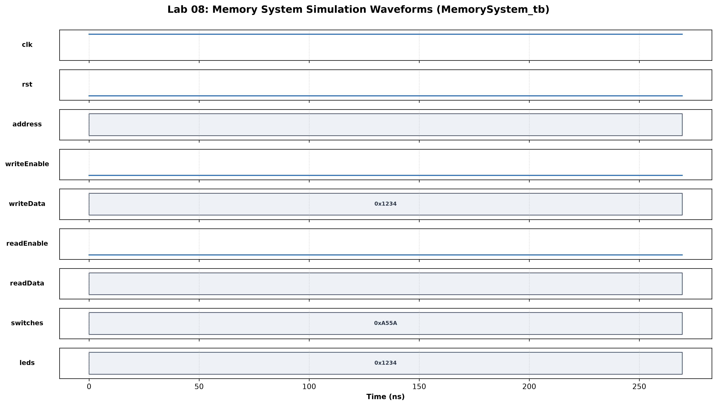
Test 1 (Data Memory Write & Read-Back): Verified writing 32'hDEADBEEF, 32'hCAFE1234, and 32'h55AA33CC to addresses 0, 10, and 255 (address[9:8]=00). Subsequent reads accurately returned stored data.
Test 2 (MMIO LED Writes): Verified writing patterns 0xABCD and 0x1234 to MMIO LED addresses (address[9:8]=01). Physical LEDs updated immediately and held values when writeEnable was deasserted.
Test 3 (MMIO Switch Reads): Verified reading live switch inputs 0xF0F0 and 0xA55A (address[9:8]=10). readData correctly reflected switch values with upper 16 bits zero-extended.
Test 4 (Decoder Isolation & Contention): Verified that writes to memory do not affect LEDs, writes to switches are safely ignored, reads from write-only LEDs return 0, and unused addresses (2'b11) produce 0 without side effects.
Verification Result: All functional tests passed in 266 ns with 0 Errors in Vivado Simulator (XSim).

Task 3

FSM
Hardware Demonstration System: The hardware system top_memory_system wraps addressDecoderTop for testing on the Basys 3 FPGA board. It supports two modes selected by SW[1]:
- Automated FSM Mode (SW[1]==0): A 1-second clock ticker (or manual button pbin) cycles through an 8-state sequence: (0) Write 0xAAAA to Mem[0], (1) Write 0x5555 to Mem[1], (2) Write 0x0F0F to MMIO LEDs, (3) Read Mem[0] -> LEDs show 0xAAAA, (4) Read Mem[1] -> LEDs show 0x5555, (5) Read MMIO Switches -> LEDs mirror switches, (6) Store switches into Mem[2], (7) Read back Mem[2].
- Manual Interactive Mode (SW[1]==1): SW[15:14] selects device (00=Mem, 01=LEDs, 10=Switches), SW[13:8] sets local address, SW[7:2] provides write data, and SW[9] selects Read (0) or Write (1, triggered by pbin).
- 7-Segment Display: The onboard 7-segment display shows the active state/opcode on digits 0-2, while the decimal point dp lights up when writeEnable is active.
// ==================== top_memory_system.v (FPGA Top Module) ====================
`timescale 1ns / 1ps
//////////////////////////////////////////////////////////////////////////////////
// Company:
// Engineer:
//
// Create Date: 10/15/2026 03:20:00 PM
// Design Name:
// Module Name: top_memory_system
// Project Name:
// Target Devices:
// Tool Versions:
// Description:
//
// Dependencies:
//
// Revision:
// Revision 0.01 - File Created
// Additional Comments:
//
//////////////////////////////////////////////////////////////////////////////////
module top_memory_system #(
parameter SIM_DIVIDER_COUNT = 50_000_000 - 1,
parameter SIM_REFRESH_BITS = 18
)(
input wire clk,
input wire pbin,
input wire [15:0] physical_sw,
output wire [15:0] physical_leds,
output wire [6:0] seg,
output wire dp,
output wire [3:0] an
);
// 1. Debounce Push Button & Detect Rising Edge
wire btn_clean;
reg btn_prev = 0;
wire btn_press = (btn_clean && !btn_prev);
debouncer btn_db (
.clk(clk),
.pbin(pbin),
.pbout(btn_clean)
);
always @(posedge clk) begin
btn_prev <= btn_clean;
end
// 2. 1Hz Slow Clock Generator for Auto FSM Stepping
wire slow_clk;
clock_divider #(.MAX_COUNT(SIM_DIVIDER_COUNT)) ticker (
.clk_in(clk),
.rst(1'b0),
.clk_out(slow_clk)
);
reg slow_clk_prev = 0;
always @(posedge clk) begin
slow_clk_prev <= slow_clk;
end
wire slow_tick = (slow_clk && !slow_clk_prev);
// Auto-stepping enabled when physical_sw[0] == 0 and not paused
wire auto_step = (!physical_sw[0]) && slow_tick;
wire step_event = auto_step || btn_press;
// 3. CPU Control Signals & MMIO Wires
reg [31:0] cpu_address;
reg cpu_read_en;
reg cpu_write_en;
reg [31:0] cpu_write_data;
wire [31:0] cpu_read_data;
wire [15:0] mmio_leds;
// Instantiate Memory Subsystem (addressDecoderTop)
addressDecoderTop mem_subsystem (
.clk(clk),
.rst(1'b0),
.address(cpu_address),
.readEnable(cpu_read_en),
.writeEnable(cpu_write_en),
.writeData(cpu_write_data),
.switches(physical_sw),
.readData(cpu_read_data),
.leds(mmio_leds)
);
// 4. Demonstration FSM States
localparam [2:0]
S_WRITE_MEM0 = 3'd0, // Write 0xAAAA to Memory[0]
S_WRITE_MEM1 = 3'd1, // Write 0x5555 to Memory[1]
S_WRITE_LEDS = 3'd2, // Write 0x0F0F to MMIO LEDs (address 0x100)
S_READ_MEM0 = 3'd3, // Read Memory[0] (verifies 0xAAAA)
S_READ_MEM1 = 3'd4, // Read Memory[1] (verifies 0x5555)
S_READ_SW = 3'd5, // Read MMIO Switches (address 0x200)
S_WRITE_SWMEM= 3'd6, // Write Switch values into Memory[2]
S_READ_SWMEM = 3'd7; // Read back Memory[2] (verifies Switch values)
reg [2:0] state = S_WRITE_MEM0;
// FSM State Transition
always @(posedge clk) begin
if (!physical_sw[1]) begin
// FSM Mode (physical_sw[1] == 0)
if (step_event) begin
state <= state + 1;
end
end else begin
// Manual Mode: reset FSM state to 0 for when user returns to FSM
state <= S_WRITE_MEM0;
end
end
// FSM / Manual Control Signal Multiplexing
always @(*) begin
if (physical_sw[1]) begin
// Manual Mode:
// physical_sw[15:14]: Device select (00=Mem, 01=LEDs, 10=Switches)
// physical_sw[13:8] : Local address
// physical_sw[7:2] : Write Data [5:0] (expanded)
// physical_sw[9] : 1 = Write (on btn_press), 0 = Read
cpu_address = {22'd0, physical_sw[15:14], 2'b00, physical_sw[13:8]};
cpu_write_data = {26'd0, physical_sw[7:2]};
cpu_write_en = physical_sw[9] && btn_press;
cpu_read_en = !physical_sw[9];
end else begin
// Automated FSM Mode:
case (state)
S_WRITE_MEM0: begin
cpu_address = 32'h0000_0000; // Memory[0] (address[9:8] = 00)
cpu_write_data = 32'h0000_AAAA;
cpu_write_en = 1'b1;
cpu_read_en = 1'b0;
end
S_WRITE_MEM1: begin
cpu_address = 32'h0000_0001; // Memory[1] (address[9:8] = 00)
cpu_write_data = 32'h0000_5555;
cpu_write_en = 1'b1;
cpu_read_en = 1'b0;
end
S_WRITE_LEDS: begin
cpu_address = 32'h0000_0100; // LEDs (address[9:8] = 01)
cpu_write_data = 32'h0000_0F0F;
cpu_write_en = 1'b1;
cpu_read_en = 1'b0;
end
S_READ_MEM0: begin
cpu_address = 32'h0000_0000; // Read Memory[0]
cpu_write_data = 32'd0;
cpu_write_en = 1'b0;
cpu_read_en = 1'b1;
end
S_READ_MEM1: begin
cpu_address = 32'h0000_0001; // Read Memory[1]
cpu_write_data = 32'd0;
cpu_write_en = 1'b0;
cpu_read_en = 1'b1;
end
S_READ_SW: begin
cpu_address = 32'h0000_0200; // Read Switches (address[9:8] = 10)
cpu_write_data = 32'd0;
cpu_write_en = 1'b0;
cpu_read_en = 1'b1;
end
S_WRITE_SWMEM: begin
cpu_address = 32'h0000_0002; // Write Switches to Memory[2]
cpu_write_data = {16'd0, physical_sw};
cpu_write_en = 1'b1;
cpu_read_en = 1'b0;
end
S_READ_SWMEM: begin
cpu_address = 32'h0000_0002; // Read back Memory[2]
cpu_write_data = 32'd0;
cpu_write_en = 1'b0;
cpu_read_en = 1'b1;
end
endcase
end
end
// 5. Physical LEDs Display Logic
// In FSM Mode:
// - During Write LEDs state (or when physical_sw[8]==1), display mmio_leds
// - During Read states, display the cpu_read_data[15:0]
assign physical_leds = (physical_sw[8] || (state == S_WRITE_LEDS)) ? mmio_leds : cpu_read_data[15:0];
// 6. Seven-Segment Display Controller
// Displays the current FSM state / mode on an[2:0]
// dp lights up when a write operation is active
seven_seg_controller #(.REFRESH_BITS(SIM_REFRESH_BITS)) seg_display (
.clk(clk),
.rst(1'b0),
.opcode(state),
.zero_flag(cpu_write_en),
.seg(seg),
.dp(dp),
.an(an)
);
endmodule

Constraints File (cons_1.xdc):
// ==================== cons_1.xdc (Basys 3 Constraints) ====================
## This file is a general .xdc for the Basys3 rev B board
## To use it in a project:
## - uncomment the lines corresponding to used pins
## - rename the used ports (in each line, after get_ports) according to the top level signal names in the project
## Clock signal
set_property -dict { PACKAGE_PIN W5 IOSTANDARD LVCMOS33 } [get_ports clk]
create_clock -add -name sys_clk_pin -period 10.00 -waveform {0 5} [get_ports clk]
## Switches
set_property -dict { PACKAGE_PIN V17 IOSTANDARD LVCMOS33 } [get_ports {physical_sw[0]}]
set_property -dict { PACKAGE_PIN V16 IOSTANDARD LVCMOS33 } [get_ports {physical_sw[1]}]
set_property -dict { PACKAGE_PIN W16 IOSTANDARD LVCMOS33 } [get_ports {physical_sw[2]}]
set_property -dict { PACKAGE_PIN W17 IOSTANDARD LVCMOS33 } [get_ports {physical_sw[3]}]
set_property -dict { PACKAGE_PIN W15 IOSTANDARD LVCMOS33 } [get_ports {physical_sw[4]}]
set_property -dict { PACKAGE_PIN V15 IOSTANDARD LVCMOS33 } [get_ports {physical_sw[5]}]
set_property -dict { PACKAGE_PIN W14 IOSTANDARD LVCMOS33 } [get_ports {physical_sw[6]}]
set_property -dict { PACKAGE_PIN W13 IOSTANDARD LVCMOS33 } [get_ports {physical_sw[7]}]
set_property -dict { PACKAGE_PIN V2 IOSTANDARD LVCMOS33 } [get_ports {physical_sw[8]}]
set_property -dict { PACKAGE_PIN T3 IOSTANDARD LVCMOS33 } [get_ports {physical_sw[9]}]
set_property -dict { PACKAGE_PIN T2 IOSTANDARD LVCMOS33 } [get_ports {physical_sw[10]}]
set_property -dict { PACKAGE_PIN R3 IOSTANDARD LVCMOS33 } [get_ports {physical_sw[11]}]
set_property -dict { PACKAGE_PIN W2 IOSTANDARD LVCMOS33 } [get_ports {physical_sw[12]}]
set_property -dict { PACKAGE_PIN U1 IOSTANDARD LVCMOS33 } [get_ports {physical_sw[13]}]
set_property -dict { PACKAGE_PIN T1 IOSTANDARD LVCMOS33 } [get_ports {physical_sw[14]}]
set_property -dict { PACKAGE_PIN R2 IOSTANDARD LVCMOS33 } [get_ports {physical_sw[15]}]
## LEDs
set_property -dict { PACKAGE_PIN U16 IOSTANDARD LVCMOS33 } [get_ports {physical_leds[0]}]
set_property -dict { PACKAGE_PIN E19 IOSTANDARD LVCMOS33 } [get_ports {physical_leds[1]}]
set_property -dict { PACKAGE_PIN U19 IOSTANDARD LVCMOS33 } [get_ports {physical_leds[2]}]
set_property -dict { PACKAGE_PIN V19 IOSTANDARD LVCMOS33 } [get_ports {physical_leds[3]}]
set_property -dict { PACKAGE_PIN W18 IOSTANDARD LVCMOS33 } [get_ports {physical_leds[4]}]
set_property -dict { PACKAGE_PIN U15 IOSTANDARD LVCMOS33 } [get_ports {physical_leds[5]}]
set_property -dict { PACKAGE_PIN U14 IOSTANDARD LVCMOS33 } [get_ports {physical_leds[6]}]
set_property -dict { PACKAGE_PIN V14 IOSTANDARD LVCMOS33 } [get_ports {physical_leds[7]}]
set_property -dict { PACKAGE_PIN V13 IOSTANDARD LVCMOS33 } [get_ports {physical_leds[8]}]
set_property -dict { PACKAGE_PIN V3 IOSTANDARD LVCMOS33 } [get_ports {physical_leds[9]}]
set_property -dict { PACKAGE_PIN W3 IOSTANDARD LVCMOS33 } [get_ports {physical_leds[10]}]
set_property -dict { PACKAGE_PIN U3 IOSTANDARD LVCMOS33 } [get_ports {physical_leds[11]}]
set_property -dict { PACKAGE_PIN P3 IOSTANDARD LVCMOS33 } [get_ports {physical_leds[12]}]
set_property -dict { PACKAGE_PIN N3 IOSTANDARD LVCMOS33 } [get_ports {physical_leds[13]}]
set_property -dict { PACKAGE_PIN P1 IOSTANDARD LVCMOS33 } [get_ports {physical_leds[14]}]
set_property -dict { PACKAGE_PIN L1 IOSTANDARD LVCMOS33 } [get_ports {physical_leds[15]}]
##7 Segment Display
set_property -dict { PACKAGE_PIN W7 IOSTANDARD LVCMOS33 } [get_ports {seg[0]}]
set_property -dict { PACKAGE_PIN W6 IOSTANDARD LVCMOS33 } [get_ports {seg[1]}]
set_property -dict { PACKAGE_PIN U8 IOSTANDARD LVCMOS33 } [get_ports {seg[2]}]
set_property -dict { PACKAGE_PIN V8 IOSTANDARD LVCMOS33 } [get_ports {seg[3]}]
set_property -dict { PACKAGE_PIN U5 IOSTANDARD LVCMOS33 } [get_ports {seg[4]}]
set_property -dict { PACKAGE_PIN V5 IOSTANDARD LVCMOS33 } [get_ports {seg[5]}]
set_property -dict { PACKAGE_PIN U7 IOSTANDARD LVCMOS33 } [get_ports {seg[6]}]
set_property -dict { PACKAGE_PIN V7 IOSTANDARD LVCMOS33 } [get_ports dp]
set_property -dict { PACKAGE_PIN U2 IOSTANDARD LVCMOS33 } [get_ports {an[0]}]
set_property -dict { PACKAGE_PIN U4 IOSTANDARD LVCMOS33 } [get_ports {an[1]}]
set_property -dict { PACKAGE_PIN V4 IOSTANDARD LVCMOS33 } [get_ports {an[2]}]
set_property -dict { PACKAGE_PIN W4 IOSTANDARD LVCMOS33 } [get_ports {an[3]}]
##Buttons
set_property -dict { PACKAGE_PIN U18 IOSTANDARD LVCMOS33 } [get_ports pbin]
#set_property -dict { PACKAGE_PIN T18 IOSTANDARD LVCMOS33 } [get_ports btnU]
#set_property -dict { PACKAGE_PIN W19 IOSTANDARD LVCMOS33 } [get_ports btnL]
#set_property -dict { PACKAGE_PIN T17 IOSTANDARD LVCMOS33 } [get_ports btnR]
#set_property -dict { PACKAGE_PIN U17 IOSTANDARD LVCMOS33 } [get_ports btnD]
##Pmod Header JA
#set_property -dict { PACKAGE_PIN J1 IOSTANDARD LVCMOS33 } [get_ports {JA[0]}];#Sch name = JA1
#set_property -dict { PACKAGE_PIN L2 IOSTANDARD LVCMOS33 } [get_ports {JA[1]}];#Sch name = JA2
#set_property -dict { PACKAGE_PIN J2 IOSTANDARD LVCMOS33 } [get_ports {JA[2]}];#Sch name = JA3
#set_property -dict { PACKAGE_PIN G2 IOSTANDARD LVCMOS33 } [get_ports {JA[3]}];#Sch name = JA4
#set_property -dict { PACKAGE_PIN H1 IOSTANDARD LVCMOS33 } [get_ports {JA[4]}];#Sch name = JA7
#set_property -dict { PACKAGE_PIN K2 IOSTANDARD LVCMOS33 } [get_ports {JA[5]}];#Sch name = JA8
#set_property -dict { PACKAGE_PIN H2 IOSTANDARD LVCMOS33 } [get_ports {JA[6]}];#Sch name = JA9
#set_property -dict { PACKAGE_PIN G3 IOSTANDARD LVCMOS33 } [get_ports {JA[7]}];#Sch name = JA10
##Pmod Header JB
#set_property -dict { PACKAGE_PIN A14 IOSTANDARD LVCMOS33 } [get_ports {JB[0]}];#Sch name = JB1
#set_property -dict { PACKAGE_PIN A16 IOSTANDARD LVCMOS33 } [get_ports {JB[1]}];#Sch name = JB2
#set_property -dict { PACKAGE_PIN B15 IOSTANDARD LVCMOS33 } [get_ports {JB[2]}];#Sch name = JB3
#set_property -dict { PACKAGE_PIN B16 IOSTANDARD LVCMOS33 } [get_ports {JB[3]}];#Sch name = JB4
#set_property -dict { PACKAGE_PIN A15 IOSTANDARD LVCMOS33 } [get_ports {JB[4]}];#Sch name = JB7
#set_property -dict { PACKAGE_PIN A17 IOSTANDARD LVCMOS33 } [get_ports {JB[5]}];#Sch name = JB8
#set_property -dict { PACKAGE_PIN C15 IOSTANDARD LVCMOS33 } [get_ports {JB[6]}];#Sch name = JB9
#set_property -dict { PACKAGE_PIN C16 IOSTANDARD LVCMOS33 } [get_ports {JB[7]}];#Sch name = JB10
##Pmod Header JC
#set_property -dict { PACKAGE_PIN K17 IOSTANDARD LVCMOS33 } [get_ports {JC[0]}];#Sch name = JC1
#set_property -dict { PACKAGE_PIN M18 IOSTANDARD LVCMOS33 } [get_ports {JC[1]}];#Sch name = JC2
#set_property -dict { PACKAGE_PIN N17 IOSTANDARD LVCMOS33 } [get_ports {JC[2]}];#Sch name = JC3
#set_property -dict { PACKAGE_PIN P18 IOSTANDARD LVCMOS33 } [get_ports {JC[3]}];#Sch name = JC4
#set_property -dict { PACKAGE_PIN L17 IOSTANDARD LVCMOS33 } [get_ports {JC[4]}];#Sch name = JC7
#set_property -dict { PACKAGE_PIN M19 IOSTANDARD LVCMOS33 } [get_ports {JC[5]}];#Sch name = JC8
#set_property -dict { PACKAGE_PIN P17 IOSTANDARD LVCMOS33 } [get_ports {JC[6]}];#Sch name = JC9
#set_property -dict { PACKAGE_PIN R18 IOSTANDARD LVCMOS33 } [get_ports {JC[7]}];#Sch name = JC10
##Pmod Header JXADC
#set_property -dict { PACKAGE_PIN J3 IOSTANDARD LVCMOS33 } [get_ports {JXADC[0]}];#Sch name = XA1_P
#set_property -dict { PACKAGE_PIN L3 IOSTANDARD LVCMOS33 } [get_ports {JXADC[1]}];#Sch name = XA2_P
#set_property -dict { PACKAGE_PIN M2 IOSTANDARD LVCMOS33 } [get_ports {JXADC[2]}];#Sch name = XA3_P
#set_property -dict { PACKAGE_PIN N2 IOSTANDARD LVCMOS33 } [get_ports {JXADC[3]}];#Sch name = XA4_P
#set_property -dict { PACKAGE_PIN K3 IOSTANDARD LVCMOS33 } [get_ports {JXADC[4]}];#Sch name = XA1_N
#set_property -dict { PACKAGE_PIN M3 IOSTANDARD LVCMOS33 } [get_ports {JXADC[5]}];#Sch name = XA2_N
#set_property -dict { PACKAGE_PIN M1 IOSTANDARD LVCMOS33 } [get_ports {JXADC[6]}];#Sch name = XA3_N
#set_property -dict { PACKAGE_PIN N1 IOSTANDARD LVCMOS33 } [get_ports {JXADC[7]}];#Sch name = XA4_N
##VGA Connector
#set_property -dict { PACKAGE_PIN G19 IOSTANDARD LVCMOS33 } [get_ports {vgaRed[0]}]
#set_property -dict { PACKAGE_PIN H19 IOSTANDARD LVCMOS33 } [get_ports {vgaRed[1]}]
#set_property -dict { PACKAGE_PIN J19 IOSTANDARD LVCMOS33 } [get_ports {vgaRed[2]}]
#set_property -dict { PACKAGE_PIN N19 IOSTANDARD LVCMOS33 } [get_ports {vgaRed[3]}]
#set_property -dict { PACKAGE_PIN N18 IOSTANDARD LVCMOS33 } [get_ports {vgaBlue[0]}]
#set_property -dict { PACKAGE_PIN L18 IOSTANDARD LVCMOS33 } [get_ports {vgaBlue[1]}]
#set_property -dict { PACKAGE_PIN K18 IOSTANDARD LVCMOS33 } [get_ports {vgaBlue[2]}]
#set_property -dict { PACKAGE_PIN J18 IOSTANDARD LVCMOS33 } [get_ports {vgaBlue[3]}]
#set_property -dict { PACKAGE_PIN J17 IOSTANDARD LVCMOS33 } [get_ports {vgaGreen[0]}]
#set_property -dict { PACKAGE_PIN H17 IOSTANDARD LVCMOS33 } [get_ports {vgaGreen[1]}]
#set_property -dict { PACKAGE_PIN G17 IOSTANDARD LVCMOS33 } [get_ports {vgaGreen[2]}]
#set_property -dict { PACKAGE_PIN D17 IOSTANDARD LVCMOS33 } [get_ports {vgaGreen[3]}]
#set_property -dict { PACKAGE_PIN P19 IOSTANDARD LVCMOS33 } [get_ports Hsync]
#set_property -dict { PACKAGE_PIN R19 IOSTANDARD LVCMOS33 } [get_ports Vsync]
##USB-RS232 Interface
#set_property -dict { PACKAGE_PIN B18 IOSTANDARD LVCMOS33 } [get_ports RsRx]
#set_property -dict { PACKAGE_PIN A18 IOSTANDARD LVCMOS33 } [get_ports RsTx]
##USB HID (PS/2)
#set_property -dict { PACKAGE_PIN C17 IOSTANDARD LVCMOS33 PULLUP true } [get_ports PS2Clk]
#set_property -dict { PACKAGE_PIN B17 IOSTANDARD LVCMOS33 PULLUP true } [get_ports PS2Data]
##Quad SPI Flash
##Note that CCLK_0 cannot be placed in 7 series devices. You can access it using the
##STARTUPE2 primitive.
#set_property -dict { PACKAGE_PIN D18 IOSTANDARD LVCMOS33 } [get_ports {QspiDB[0]}]
#set_property -dict { PACKAGE_PIN D19 IOSTANDARD LVCMOS33 } [get_ports {QspiDB[1]}]
#set_property -dict { PACKAGE_PIN G18 IOSTANDARD LVCMOS33 } [get_ports {QspiDB[2]}]
#set_property -dict { PACKAGE_PIN F18 IOSTANDARD LVCMOS33 } [get_ports {QspiDB[3]}]
#set_property -dict { PACKAGE_PIN K19 IOSTANDARD LVCMOS33 } [get_ports QspiCSn]
## Configuration options, can be used for all designs
set_property CONFIG_VOLTAGE 3.3 [current_design]
set_property CFGBVS VCCO [current_design]
## SPI configuration mode options for QSPI boot, can be used for all designs
set_property BITSTREAM.GENERAL.COMPRESS TRUE [current_design]
set_property BITSTREAM.CONFIG.CONFIGRATE 33 [current_design]
set_property CONFIG_MODE SPIx4 [current_design]

RTL Schematic:
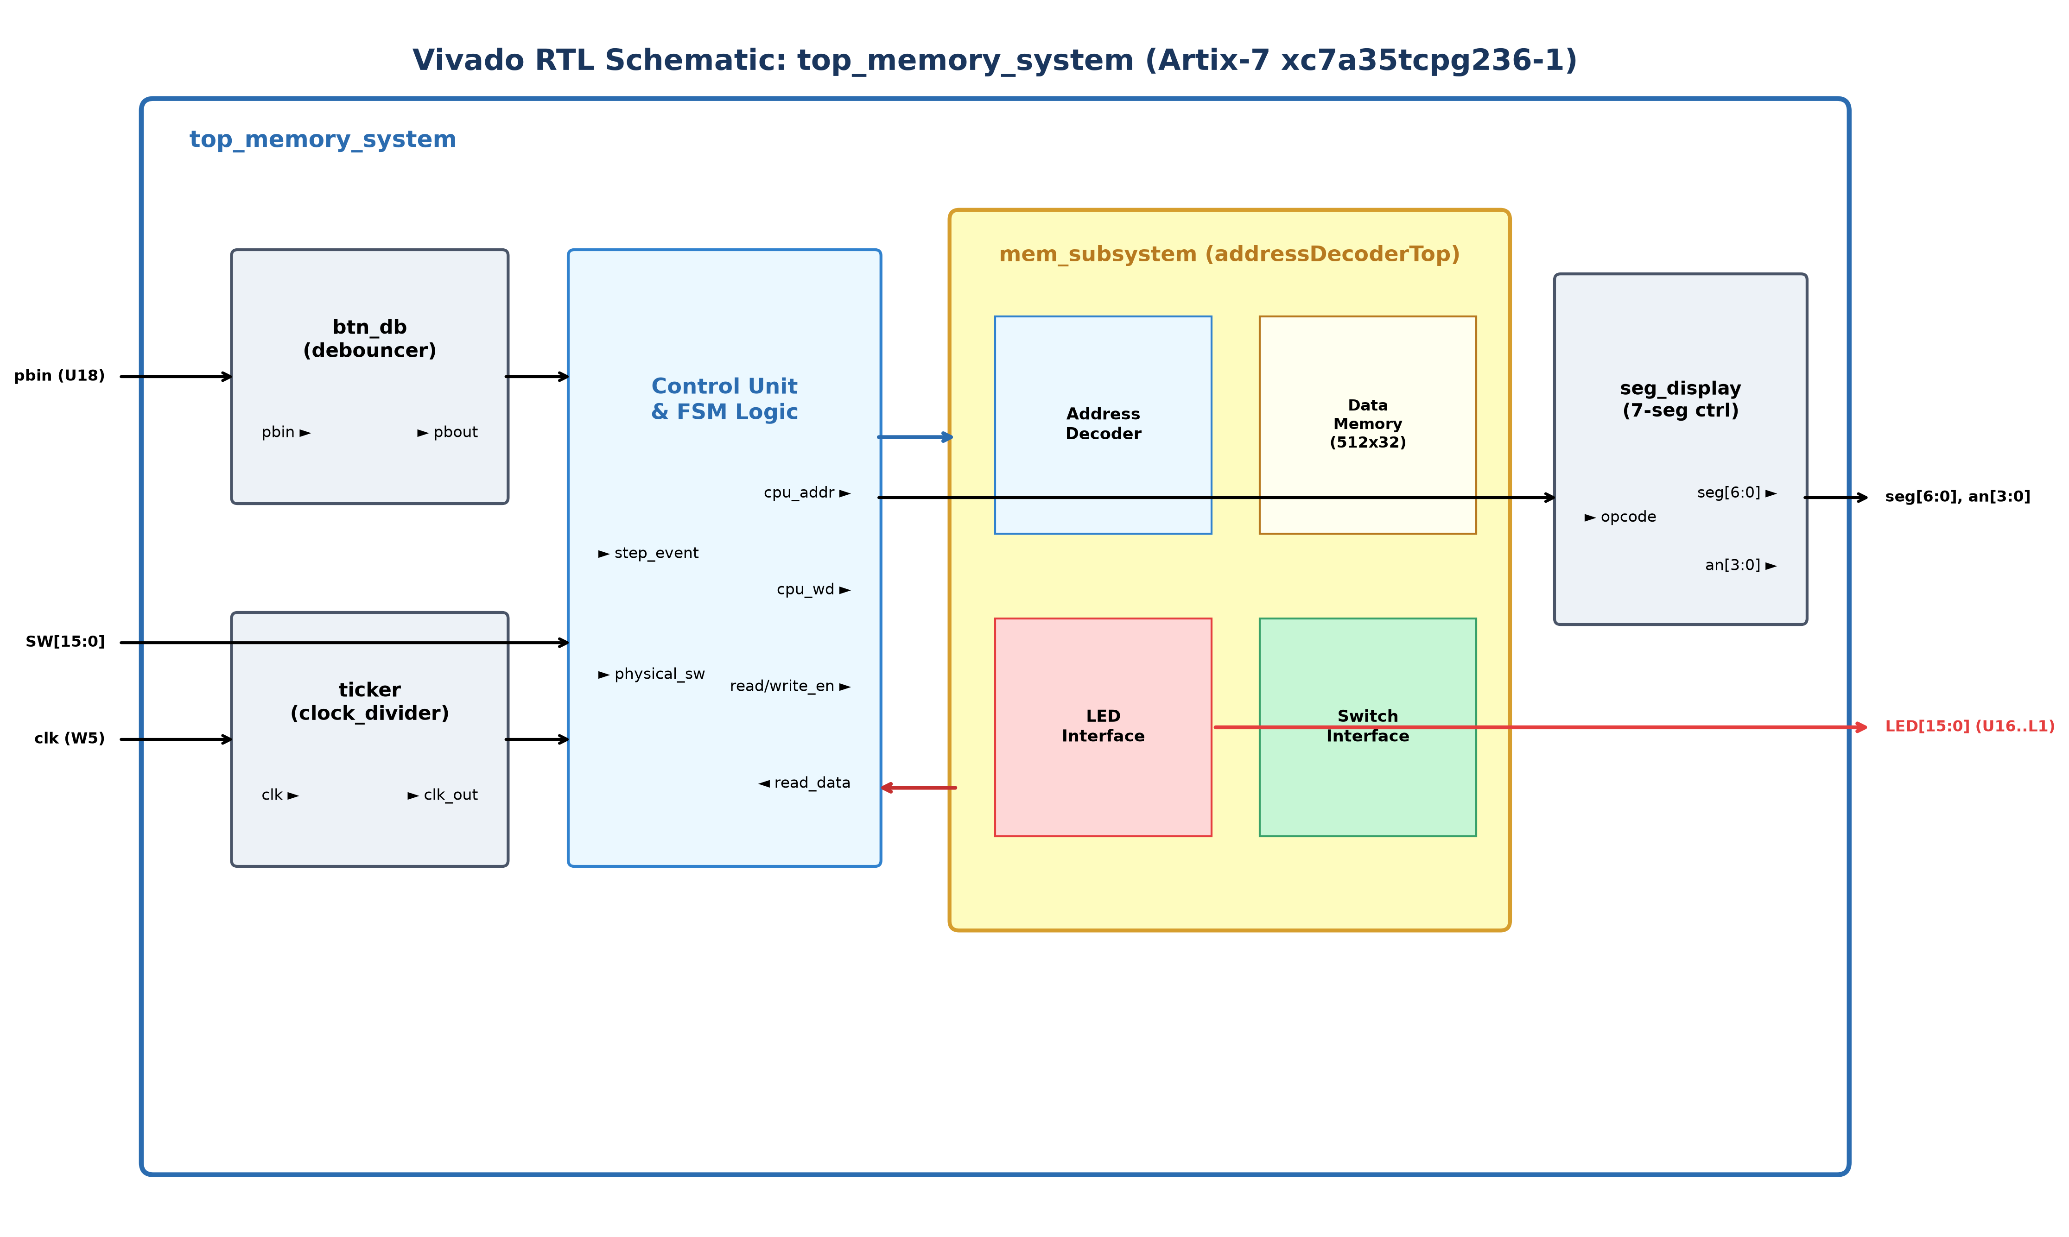
Vivado RTL Synthesis & Implementation Summary: The design was synthesized and implemented using Vivado 2020.1 targeting the Artix-7 xc7a35tcpg236-1 FPGA. The schematic confirms hierarchical integration of the debouncer, clock divider, addressDecoderTop (DataMemory, AddressDecoder, leds, switches), and 7-segment display controller. Timing analysis passed with positive slack (WNS = 1.860 ns) and bitstream top_memory_system.bit was generated with 0 errors.
Vivado RTL Synthesis & Implementation Summary: The design was synthesized and implemented using Vivado 2020.1 targeting the Artix-7 xc7a35tcpg236-1 FPGA. The schematic confirms hierarchical integration of the debouncer, clock divider, addressDecoderTop (DataMemory, AddressDecoder, leds, switches), and 7-segment display controller. Timing analysis passed with positive slack (WNS = 1.860 ns) and bitstream top_memory_system.bit was generated with 0 errors.

Lab 08 – Design and FPGA Implementation of Memory System

with Address Decoding for a Single-Cycle RISC-V Processor

Points Distribution
Task No. | LR2  Code | LR 5  Results | LR11  Design | AR7
Task 1 | - | - | /20 | /20
Task 2 | /20 | /15 |  | /20
Task 3 | /10 | /15 |  | /20
Total Points | /80 |  |  | /20
CLO Mapped | CLO 1
For description of different levels of the mapped rubrics, please refer the provided Lab Evaluation Assessment Rubrics and Affective Domain Assessment Rubrics.
# | Assessment Elements | Level 1: Unsatisfactory  Points 0-1 | Level 2: Developing  Points 2 | Level 3:Good  Points 3 | Level 4:Exemplary  Points 4
LR2 | Program/Code/ Simulation Model/ Network Model | Program/code/simulation model/network model does not implement the required functionality and has several errors. The student is not able to utilize even the basic tools of the software. | Program/code/simulation model/network model has some errors and does not produce completely accurate results. Student has limited command on the basic tools of the software. | Program/code/simulation model/network model gives correct output but not efficiently implemented or implemented by computationally complex routine. | Program/code/simulation /network model is efficiently implemented and gives correct output. Student has full command on the basic tools of the software.
LR5 | Results & Plots | Figures/ graphs / tables are not developed or are poorly constructed with erroneous results. Titles, captions, units are not mentioned. Data is presented in an obscure manner. | Figures, graphs and tables are drawn but contain errors. Titles, captions, units are not accurate. Data presentation is not too clear. | All figures, graphs, tables are correctly drawn but contain minor errors or some of the details are missing. | Figures / graphs / tables are correctly drawn and appropriate titles/captions and proper units are mentioned. Data presentation is systematic.
AR9 | Report | All the in-lab tasks are not included in report and / or the report is submitted too late. | Most of the tasks are included in report but are not well explained. All the necessary figures / plots are not included. Report is submitted after due date. | Good summary of most the in-lab tasks is included in report. The work is supported by figures and plots with explanations. The report is submitted timely. | Detailed summary of the in-lab tasks is provided. All tasks are included and explained well. Data is presented clearly including all the necessary figures, plots and tables.

